**PROG8170 SOFTWARE QUALITY ASSURANCE TECHNIQUES**

**Assignment 1**

**Name:** Shravani Gandla

**Student number:** 8697289

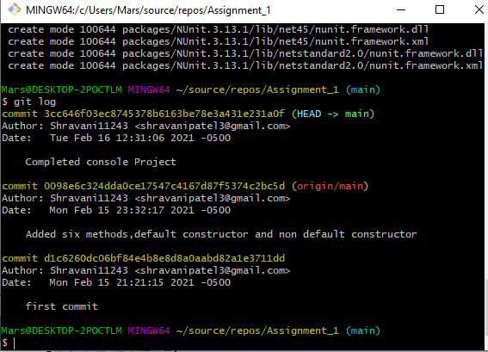

**Output:**

